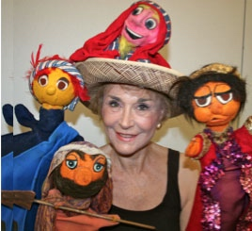I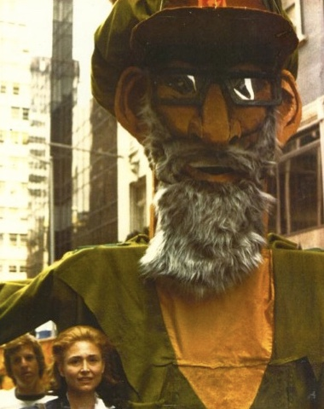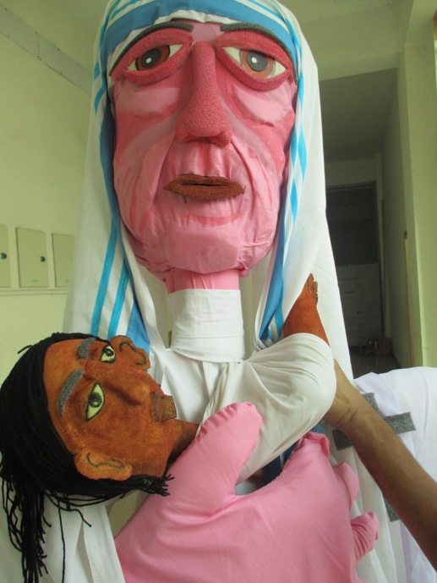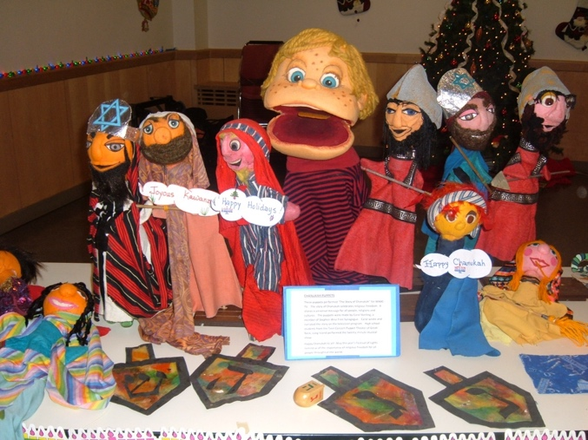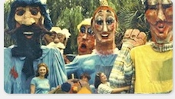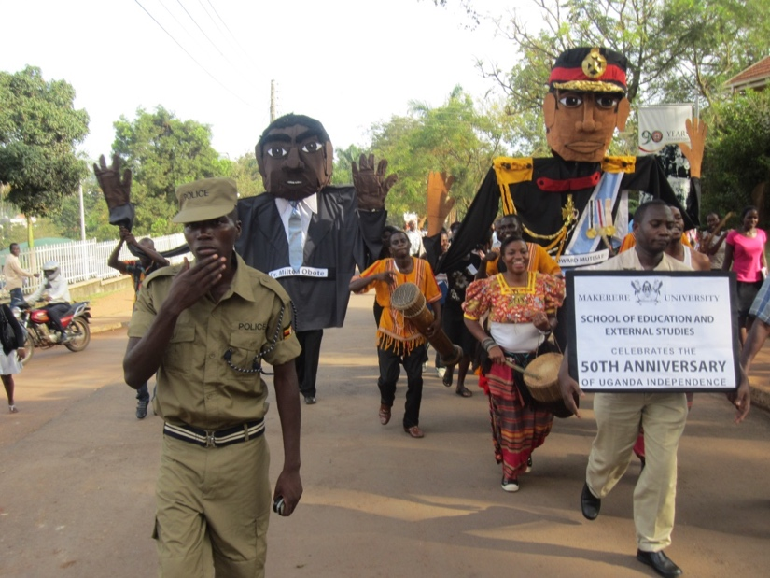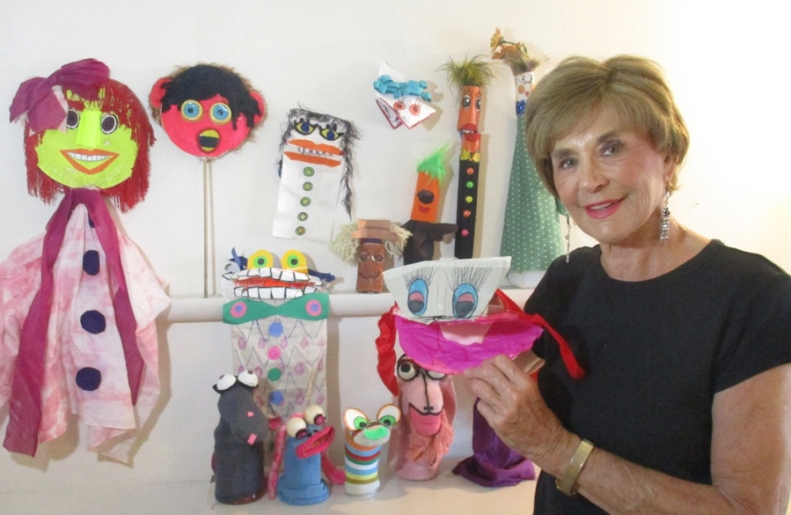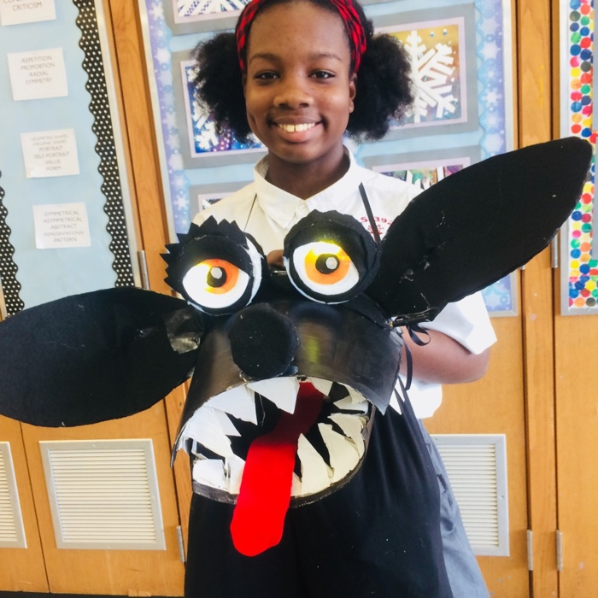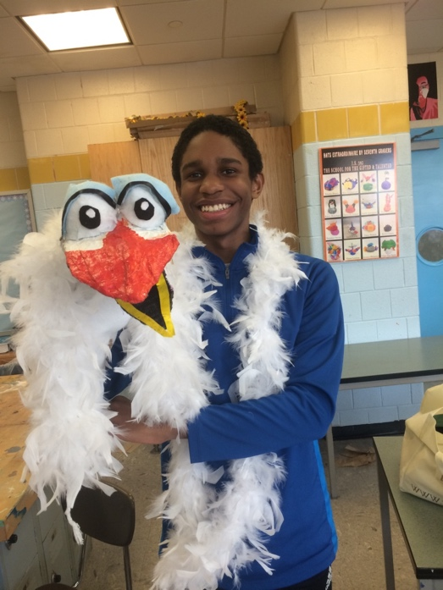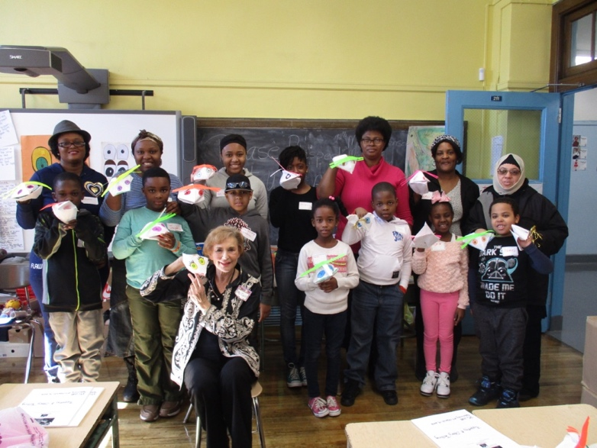

L: Carol Sterling with 15’ giant puppet of Mother Theresa and baby she taught drama students in India for street parade.

R: Display of puppets made by Carol Sterling for Chanukah/Christmas/Kwanzaa Holiday party at Senior Center. NYC 15

Left: Carol Sterling with puppets she made for WABC-TV “The Story of Chanukah.”

Right: Carol Sterling

with 15’ giant puppet she taught students to make of Rabbi Shlomo Goren for Salute to Israel Parade.

L: Carol Sterling with 15’ giant puppets she taught community members to make for Spoleto Festival, Charlestown, South Carolina. Puppets depict an artist, conductor, opera singer, dancer and flautist.

15’ giant puppets Carol Sterling taught students to make at Makerere University in Kampala, Uganda. They depict historically important Ugandan leaders.

Carol Sterling with puppets created from recycled materials, e.g., paper plates, paper bags, cardboard rolls, envelopes, socks, etc.

L and R: Carol Sterling teaches 7th graders how to make a Hyena and bird puppet for student production of The Lion King.

Carol Sterling teaches class of parents and children that focuses on communication, camaraderie, cooperation, creativity, and puppet skit improvisation.